Reading Curriculum Intent, Implementation and Impact
Intent
Here at the Downley School we teach an enriching and diverse reading-based curriculum. We use a wide range of high-quality texts to engage and inspire reading and writing. At The Downley School we aim to teach the skills needed together with fostering a love and appreciation of reading. We aim to create an environment where all children, no matter their background and starting point, read for enjoyment.
In reading and writing lessons at The Downley School, our lessons are based on curating high-quality book talk based on a diverse range of books. This discussion is taught through explicit and precise modelling of the skills needed (prediction, sequencing, summarising, retrieval and inference). Our lessons are not based solely on questions, but rather building the skills needed through visualisation, enriching discussion and sharing of opinions in a nurturing and engaging environment.
At The Downley School we are passionate about reading and know the importance of promoting reading for pleasure and purpose and that it goes deeper than just being celebrated on World Book Day. Our teachers have a passion for reading themselves and work hard to instil a love of reading and books in all our children. Reading is continuously promoted and celebrated and is at the heart our English curriculum. In all classes, adults and children read together and share books. A breadth of books are used to explore diversity and different genres.
Implementation
At The Downley School we are working to ensure quality and consistency in the teaching of reading across the whole school. Every child will encounter high quality teaching and lessons that are inspiring, engaging and carefully planned and delivered for them to achieve. To do this, we ensure that all staff at The Downley School have expert knowledge and feel confident in teaching high quality reading lessons.
We are developing a whole school culture where there is a love of reading, and reading for both pleasure and purpose is highly valued; we aim to inspire every child to be a reader. We do this in several ways throughout the school day:
- Every teacher reads aloud to their class every day with a designated spot on the timetable,
- Daily reading lessons,
- All classes have a weekly slot where they can visit the school library,
- Class bookshelves.
Reading lessons
The whole school takes part in taught reading lessons, which are separate from the daily writing lesson. In Early Years and KS1, this is through our phonics scheme Little Wandle and in KS2 reading lessons are 5 times a week. The focus of these lessons is to promote high quality book talk, deep understanding, and engagement in a range of texts that cover diversity, inclusion in line with the school’s values.
These lessons include an abundance of high-quality book talk and rich discussion, fluency as well as an element of written comprehension. These lessons are planned and taught to model and guide the children in visualising, predicting and constructing a mental model of a specific text to help understand its meaning and wider context. Teachers explicitly model skills needed, and children given chances to practice both guided and independently: there is a focus on vocabulary and how it can be used to enhance meaning and effect.
Pupils will become better at each of the assessed aspects of reading when they read, think deeply about, and respond to texts through discussion and in writing. The knowledge, experience and insight that pupils gain from reading a text alongside the teacher supports them to understand and enjoy the texts they experience in both assessments and for pleasure.
Developing Reading for Pleasure and Purpose
Throughout the school day, small activities and practices take place to promote a love of reading, expose children to new and varied books. This includes a chance to talk and share books with their peers and adults. In the classroom, the teacher is an influencer and works to promote all aspects of reading with their class.
This looks like:
- Adults reading aloud daily,
- A writing curriculum which is based on high-quality texts,
- Informal book talk,
- Recommendations,
- Adults showing interest in what the children are reading,
- Praising reading,
- Children are encouraged to explore the books,
- Read for pleasure,
- Share their reviews with their peers,
- Creating a positive culture around reading for pleasure and for purpose.
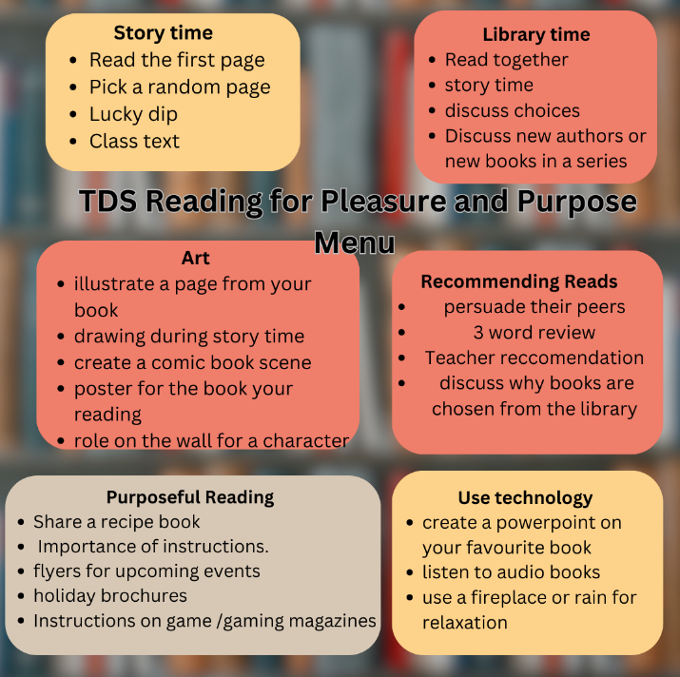​
Book corners
At The Downley School we promote reading in the classroom. We create exciting and enticing environments full of books that the children are eager to read. In every classroom there is a mini library, a place for children to browse the best books, revisit the ones that the teacher has read to them, and borrow books to read or retell at home.
Book corners are interesting and contain age-appropriate books which feature well-known fictional characters or are new and tempting books that have been read in lessons.
In every classroom:
- Every book in a book corner should be worth reading.
- The books are facing outwards towards children and are at eye level.
- The number of books on display are limited and the ones that are, are inspiring and up to date.
- The more choice that is presented, the less children are likely to engage.
- The shelves are routinely refreshed to highlight topics, titles, or authors.
- Books from different cultures, countries showing diversity are available.
Home – School Links Reading
- Reading books
- Reading Logs
Impact
Assessment
In Key Stage 1, children are assessed through the Little Wandle phonics assessments ( see below) and through teacher assessment against the end of year objectives for reading.
In Key Stage 2, reading is summatively assessed through PiXL reading comprehension assessments three times a year. However, children are continually assessed through teacher judgement against the end of year objectives for reading. We also use the Collins fluency assessment, to support children to be placed on appropriate book levels until they become free readers.
They understand that when we learn together, we grow together and succeed together.

