Writing Curriculum Intent, Implementation and Impact
Intent
Here at the Downley School, we teach an enriching and diverse book-based curriculum. We use a wide range of high-quality texts to engage and inspire reading and writing. At The Downley School we aim to teach the skills needed together with fostering a love and appreciation of reading and writing. We aim to create an environment where all children, no matter their background and starting point, read and write for enjoyment and understand that it is an essential skill for different purposes and audiences.
An integral aim for our teaching is to develop high standards of literacy in all children, essential for them to access the wider world and communicate freely. Pupils will be given opportunities to use their progressing English skills within a broad and balanced curriculum. This will provide opportunities to consolidate and practise literacy skills across a broad range of curriculum topics to embed lifelong learning and skills. English skills do not stand alone but are an integral part of all learning and wider life.
Writing
At The Downley School, we believe that every child is a writer. We are passionate about developing every child’s knowledge, motivation and confidence in their writing. We have chosen HFL Education’s ESSENTIALWRITING as the basis of our writing curriculum for Years R-6. This is an ambitious and progressive writing scheme which provides our children with opportunities and tools to write for a range of specific purposes and authentic audiences. As a result, our children feel inspired and ready to write high-quality outcomes within the classroom but also have the knowledge, strategies and confidence to choose to write in their own lives.
Implementation
Each year group has 13-16 teaching units, all of which use diverse and high-quality literature as good examples of writing craft and to help to motivate or inspire children to write. Alongside these units we look for ‘real life’ opportunities to write about such as trips or special events
ESSENTIALWRITING is fully aligned with the National Curriculum for English including writing composition, vocabulary, grammar & punctuation for each year group. Each writing unit is progressively structured and centred around the different writing purposes: to entertain; to inform; to persuade and to discuss. The writing purposes are also progressively sequenced across the school.
​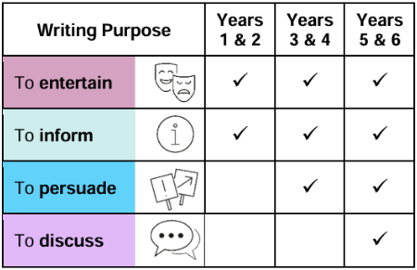
Alongside ESSENTIALWRITING, at The Downley School, we have adopted Essential Spelling as the basis of our spelling curriculum. ESSENTIALWRITING supports our children to apply this learning in context and build their spelling confidence. Writing models reflect age-appropriate spelling objectives and children are taught how to monitor the accuracy of their writing. Handwriting is also taught. We use Little Wandle and later Oak Academy to ensure that every child gains sufficient fluency for writing, with knowledge of accurate letter formation and how to join letters so that they can meet the National Curriculum expectations for each key stage.
Impact
In ESSENTIALWRITING lessons, the stages of the writing process are given dedicated teaching time to enable all children to behave as writers. They learn about these vital stages of writing and, within key stage one, they are given time to collect their ideas, plan and compose their writing orally before writing. They are given regular opportunities to share their writing by reading and rereading it aloud. Children regularly discuss what they have written with their teacher and their peers to ensure their meaning is clear. They are taught to proof-read to make corrections in spelling, grammar and punctuation so that their readers can follow their writing with clarity. Vitally, within all writing units, the children are given time to publish their writing to share it and celebrate their success with their intended audience.
In lower key stage two, the children continue to discuss and record their ideas for writing and ‘read as writers’ to study 'writerly' craft and apply similar techniques to their own writing. Oral rehearsal for writing is embedded throughout the writing teaching sequence and the children build a varied and rich vocabulary and increasing range of sentence structures to use within their compositions. Dedicated time is provided to teach the children how to evaluate and edit their writing, thinking carefully about their language choices and the intended effect on the reader. Proofreading strategies are used to check for spelling and punctuation errors to ensure that their final versions are ready to be shared with their audience.
In upper key stage two, a keen focus on the authentic purpose and audience for their writing ensures that the children are acutely aware of an appropriate selection of vocabulary and grammar, with conscious control of sentence structure. The children have time to study the 'writerly' craft of a range of authors, noting and developing their own ideas to develop independence in writing. They understand how their language choices can be used to change and enhance meaning for their intended audience. Children are successful at evaluating and editing their writing and can propose changes to their own and others’ writing, based on its effectiveness and the needs of the reader. They can proofread for spelling and punctuation errors to ensure that their writing is ready for sharing with their chosen audience. All writing is shared and celebrated, with feedback sought from their readers to recognise how they have been successful writers and what they could do to improve even further.
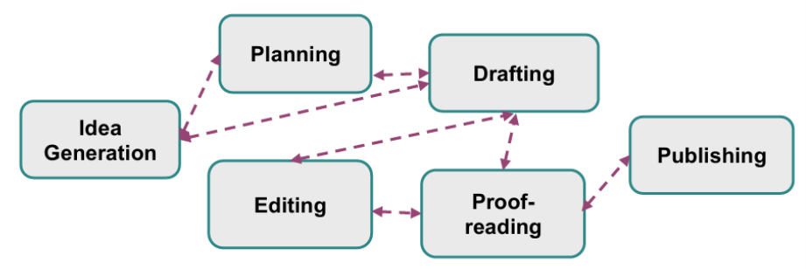
Assessment
Teachers assess children's writing through a range of marking and feedback strategies. This allows them to give children immediate feedback or adapt the planning for the next day to address common errors or misconceptions.
Writing is also assessed through writing moderation meetings, where writing is standardised to the end of year objectives across the year group, the phase, the school or across other schools in the Trust and local areas.
To ensure high-quality teaching and learning is taking place consistently across the school, regular learning walks and book looks are conducted by the English Leader and other senior leaders.
Senior leaders and governors review this information, and this informs discussions and decisions around provision for all learners.
They understand that when we learn together, we grow together and succeed together.

